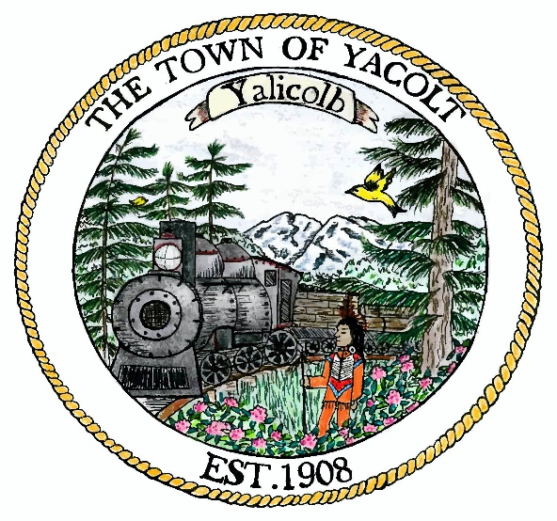

**Yacolt Town Council Special Meeting/ Budget Workshop**

**Yacolt Town Hall**

**Monday, September 19th at 6pm**

**Agenda**

1. Right of Way Permit Review for Approval

2. Town Park Improvements

3. Budget Workshop